Independent Living Centers (ILC) – Deaf Services
Connecticut has five (5) Independent Living Centers (ILCs) that serve the whole state.
These centers provide tools, resources, and supports for integrating people with disabilities fully into their communities to promote equal opportunities, self-determination, and respect.
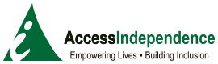
Access Independence
ASL Advocates- Sue Catale (part-time) & Katie Smolinsky
300 Long Beach Blvd. Suite #1 Stratford, CT 06615
203-378-6977 ext. 111
scatale@accessinct.org
ksmolinsky@accessinct.org

Serving Bridgeport, Darien, Easton, Fairfield, Greenwich, Monroe, New Canaan, Norwalk, Stamford, Trumbull, Weston, Westport, and Wilton.
Center for Disability Rights
ASL Advocate- Sue Catale (part-time)
369 Highland St. West Haven, CT 06516
(203) 916-9012
sue@cdr-ct.org

Serving Ansonia, Bethany, Branford, Chester, Clinton, Cromwell, Deep River, Derby, Durham, East Haddem, East Hampton, East Haven, Essex, Guilford, Haddam, Hamden, Killingworth, Lyme, Madison, Middlefield, Middletown, Meriden, Milford, New Haven, North Branford, North Haven, Old Lyme, Old Saybook, Orange, Portland, Seymour, Shelton, Stratford, Wallingford, West Haven, Westbrook, and Woodridge

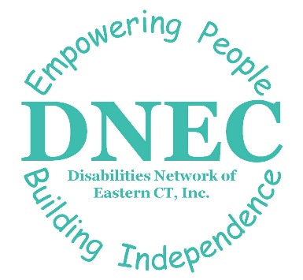
Disabilities Network of Eastern CT (DNEC)
ASL Advocate –
Brynn Hickey
19 Ohio Ave. Norwich, CT 06360
(860) 237-4515 (videophone)
bhickey@dnec.org

Serving Ashford, Bozrah, Brooklyn, Canterbury, Chaplin, Colchester, Columbia, Coventry, East Lyme, Eastford, Franklin, Griswold, Groton, Hampton, Killingly, Lisbon, Lebanon, Ledyard, Mansfield, Montville, New London, North Stonington, Norwich, Plainfield, Pomfret, Preston, Putnam, Salem, Scotland, Sprague, Sterling, Stonington, Thompson, Union, Voluntown, Waterford Windham, and Woodstock.
Independence Northwest
ASL Advocate - Kassey Neason
1183 New Haven Rd. Suite 200 Naugatuck, CT 06770
(203) 490-2373 (videophone)
Kassey.Meason@indnw.org

Serving Barkhamsted, Beacon Falls, Bethel, Bethlehem, Bridgewater, Brookfield, Canaan, Cheshire, Colebrook, Cornwall, Danbury, Goshen, Hartland, Harwinton, Kent, Litchfield, Middlebury, Morris, Naugatuck, New Fairfield, New Hartford, New Milford, Newtown, Norfolk, North Canaan, Oxford, Prospect, Redding, Ridgefield, Roxbury, Salisbury, Sharon, Sherman, Southbury, Thomaston, Torrington, Warren, Washington, Waterbury, Watertown, Winchester, Wolcott, and Woodbury.
Independence Unlimited
ASL Advocate - Shayna Wilson
151 New Park Ave.
North Annex | Suite D Hartford, CT 06106
(860) 724-2742 (Videophone)
SWilson@independenceunlimited.org

Serving Granby, East Granby, Suffield, Windsor Locks, Windsor, Bloomfield, Ellington, Simsbury, Canton, Avon, West Hartford, Hartford, Farmington, New Britain, Plainville, Bristol, Burlington, Plymouth, Berlin, Wethersfield, Rocky Hill, East Hartford, Glastonbury, Manchester, Marlborough, Hebron, Andover, Bolton, Vernon, Tolland, Endfield, East Windsor, Newington, South Windsor, Southington, Somers, Stafford, Tolland, Willington.

